# Module 2 – Introduction to traffic simulation

# CIVL6415 Week 4 Notes

## Offline vs Online

* Offline evaluation

System Design

Scenarios

Simulator

Measures of Effectiveness

* Online decisions

Traffic Management Centre

Information

Travel Demand

Surveillance

Control

Traffic Conditions

Supply

**Information Loop**

**Traffic Control Loop**

## Static traffic models

### **Four Steps modelling**

Step 1. Estimate trips produced and attracted in each zone

Step 2. Find $O$- $D$ flows

Step 3. Consider alternative transport modes (mode split)

Step 4. Traffic assignment (Route choice for $O$- $D$ car flows)

* Static traffic models with travel time functions
* Equilibrium

### Roadway performance function

* Space representation

Links

Discrete

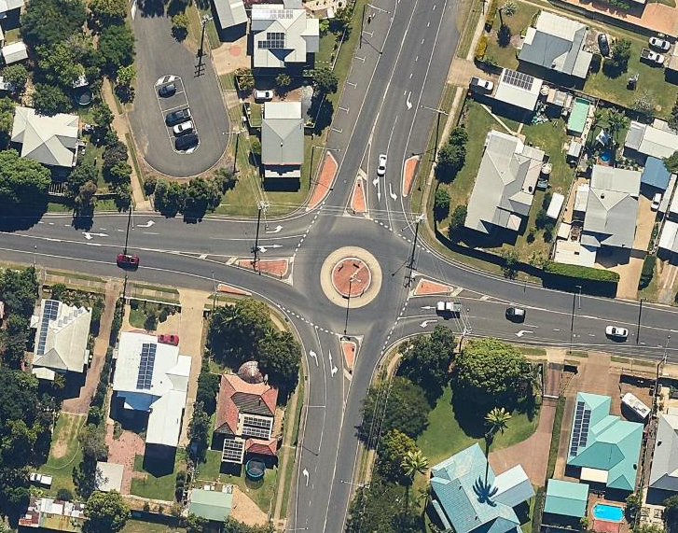

Continuous

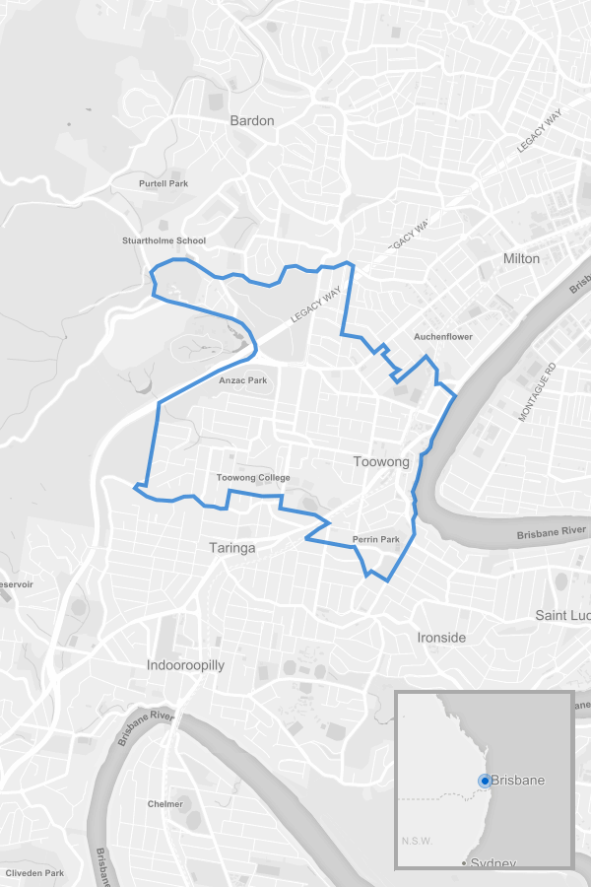

Regional

where

Final link travel time

Original (free-flow) link travel time

Coefficient (usually 0.15)

assigned traffic volume

the link capacity

exponent (usually 4.0)

### Graph, Links, Paths

* **Graph**

Ordered pair of sets representing network connections

Origin centroid: 1

Destination centroid: 4

* **Path**

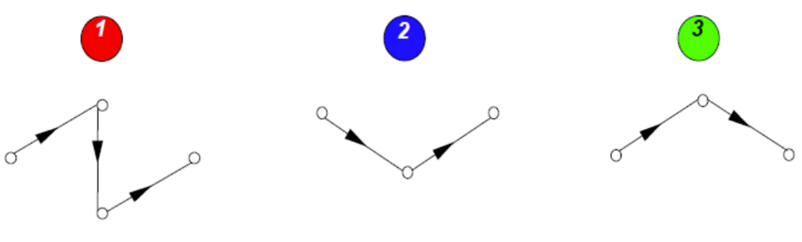Sequence of links representing “typical” trips allowed by the supply system modelled

Path set

### Path flows and link flows

Simulation period= simulation life = 1 hour

* Path flow

(average) flow along path during the simulation period

Path flows are propagated simultaneously on each link belonging to the path